B-SAFE Tool Updater User Guide
The B-SAFE Tool Updater is an Excel application designed to use the most recent ICTV and BacDive data to generate a new version of the B-SAFE Tool. This guide details how to use this Tool Updater application.

ICTV Data Download
ICTV data can be downloaded from the following site: Virus Metadata Resource (VMR) | ICTV
Currently, there is a “Download Current Virus Metadata Resource (VMR)” button that can be clicked to download ICTV data.
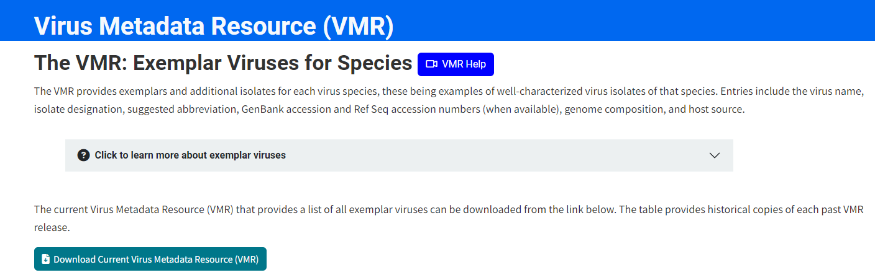
Clicking the Download button brings users to the following site, where the “Download file” button needs to be clicked to download the ICTV data.
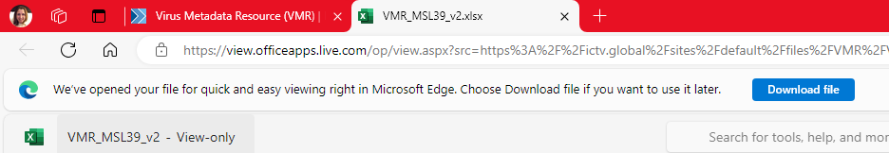

BacDive Data Download
BacDive data can be downloaded from the BacDive website, but a tool written in R must be used to get all of the data of interest in the most efficient manner.
Go to the BacDive site: BacDive | The Bacterial Diversity Metadatabase (dsmz.de)

Click the “Advanced search” button:

In the left pane of the site, specify that “Type strain” must be equal to “yes”.
Click the “Submit” button.
Click the “Download table as CSV” button in the right pane.
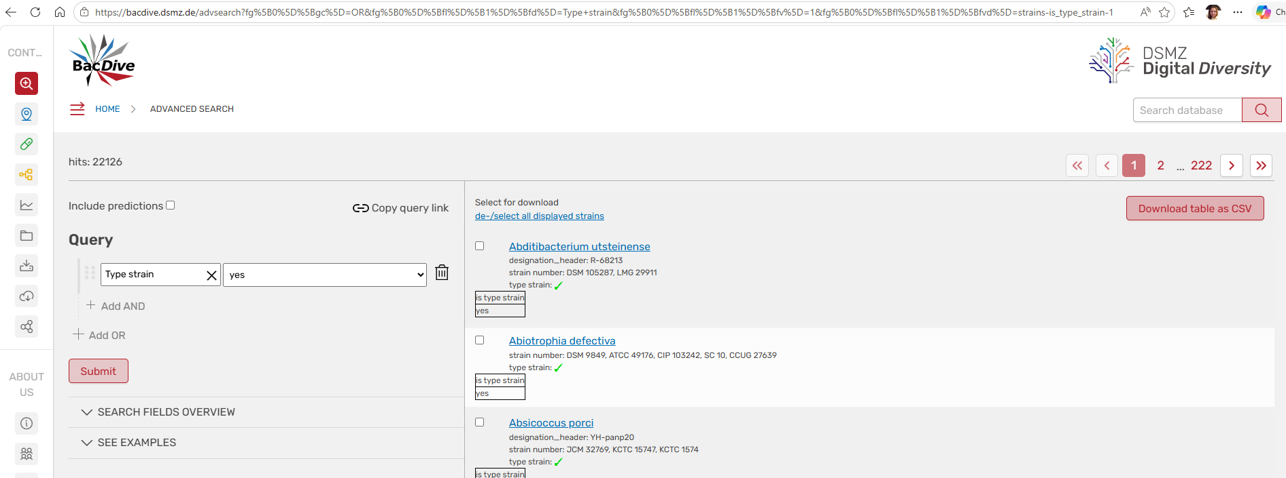

A CSV file will be downloaded and will list Agents where Type Strain = “yes” (1).
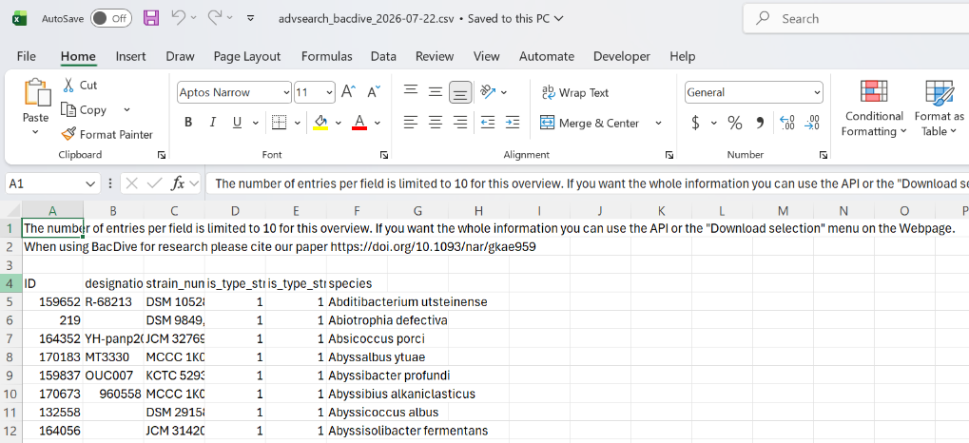
The next step is to run an R script that leverages the agent list csv just downloaded to download BacDive agent data where Type Strain = Yes. NOTE: R and RStudio need to be installed on your system.
Prior to the first execution of the R script, the following R packages need installed (by running commands detailed below from RStudio):
install.packages('curl')
install.packages('httr')
install.packages('BacDive')

Create a BacDive User account.
Open the provided rmd R script file (below) in RStudio.
Update USRNAME to list your BacDive account email.
Update PWD to list your BacDive account password
Update type table to be the name of the file downloaded previously from BacDive site. NOTE: CSV must be saved in the same folder as the rmd file.
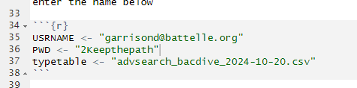
Save the updated rmd file

From RStudio select Run->Restart R and Run All Chunks.
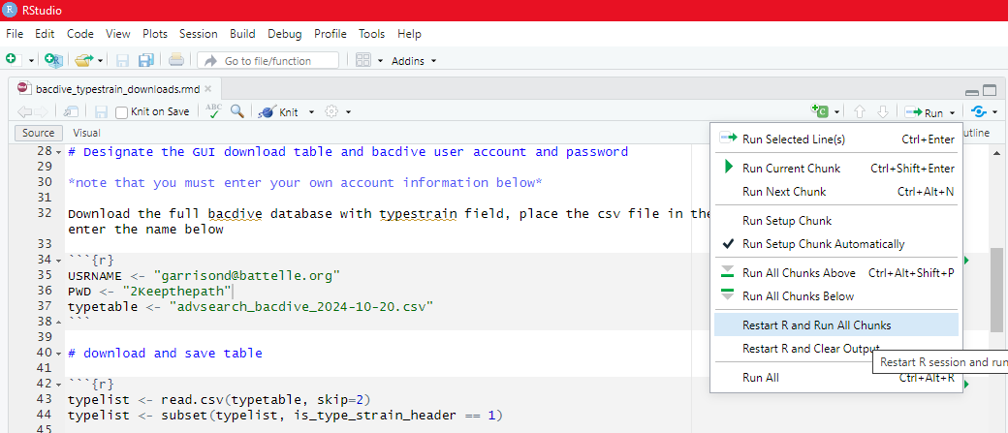
After the code run is complete in the same folder where your:
advsearch_bacdive_<date>
bacdive_typestrain_downloads.rmd
files are stored, there will be a:
bacdive_type_strains_v2.csv
This file includes BacDive data that B-SAFE needs.
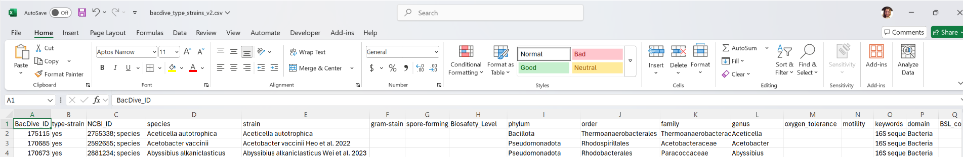

Replacing B-SAFE Updater Data
Make a copy of the current B-SAFE Updater Tool (xlsm file).
Rename the file to indicate that this version will be newer than the last (e.g., to simply update the BacDive and ICTV data, you might rename from B-SAFE Updater v1-1.xlsm to B-SAFE Updater v1-2.xlsm)
Open the new version of the B-SAFE Updater xlsm file.

Click the “Clear ICTV and BacDive Data”. This will delete the worksheets with data from BacDive and ICTV imports.
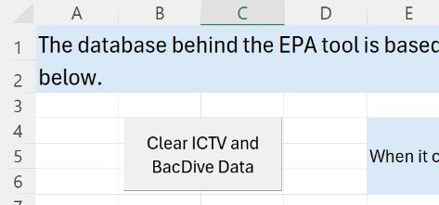
Be sure that the steps in BacDive Download section have been completed.
Click the “Import BacDive Data” button.
You will be prompted for a “BacDive Download Date”. This is the date that the R script was used to obtain the CSV file. If you are unsure, you can look at the “Date Modified” of the bacdive_type_strains_v2.csv file. Provide the Date.
Click the OK button on the form.
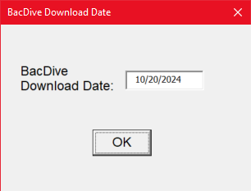
You will be prompted to browse to the BacDive Export File. Browse to the bacdive_type_strains_v2.csv file mentioned previously.
Click the Open button.
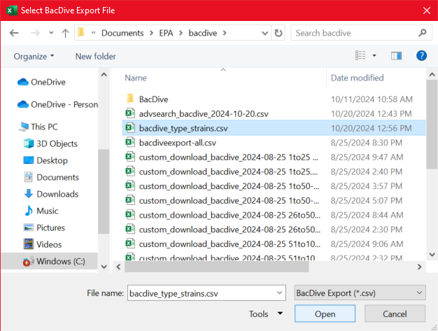
The process may take a few minutes, but when it is complete, there will be two new worksheets in the Updater workbook: bacdive_type_strains_v2 (identical to the bacdive_type_strains.csv file that was imported) and BacDive-Culled (bacdive_type_strains without the agents that are less applicable and with logic applied to supplement data and to populate needed B-SAFE fields).
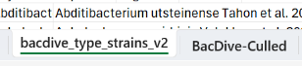
BacDive Data is updated. It is time to update ICTV data. Be sure that the steps in ICTV Data Download have been completed. Open the downloaded file to find version date in the Version sheet in a format similar to the one below. Make note of this version date.
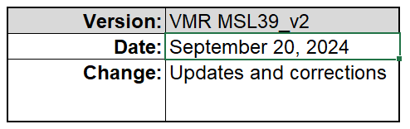
Delete the Version sheet. The import routine will expect the data sheet to be the first worksheet in the ICTV file. Save and close ICTV file.
Click the “Import ICTV Data” button.

You will be prompted for an “ICTV Version Date”. This is the date noted previously from downloaded file. Provide the Date.
Click the OK button on the form.
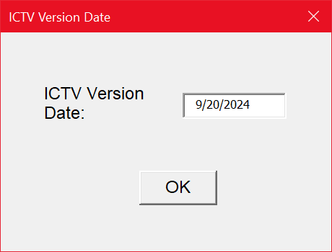
You will be prompted to browse to the VMR Export File. Browse to the ICTV file mentioned previously.
Click the Open button.
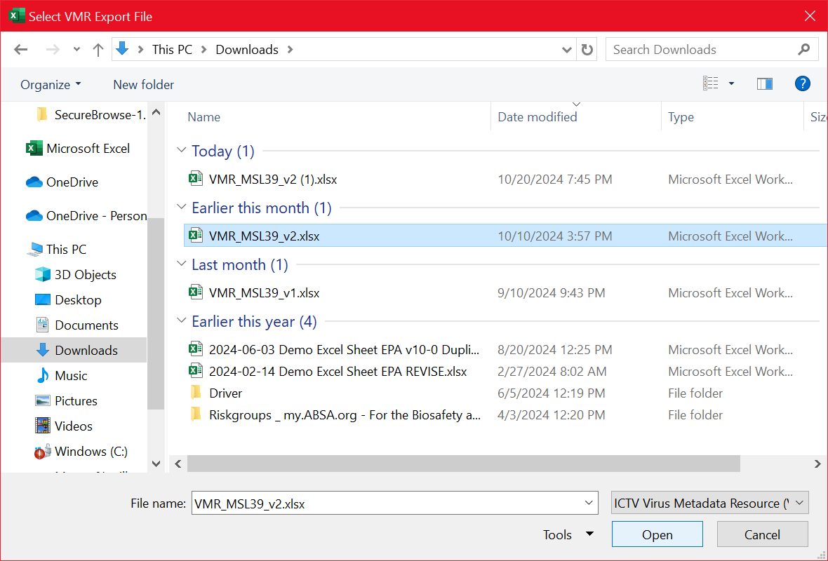
The process may take a few minutes, but when it is complete, there will be two new worksheets in the Updater workbook: <ICTV Download Filename> (identical to the ICTV file that was imported) and <ICTV Download Filename> -Culled (<ICTV Download Filename> without the agents that are less applicable and with logic applied to supplement data and to populate needed B-SAFE fields).
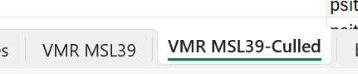

Updating B-SAFE Tool
After ICTV and BacDive data has been downloaded and imported. It is up to an SME to make any necessary adjustments to the Additions, Modifications, and Remove worksheets in the B-SAFE Tool Updater. After SME updates are complete, it is time to update the B-SAFE Tool.
Make a copy of the current version of the B-SAFE Tool and rename it to indicate that it will be the next version (e.g., if the current version of the B-SAFE tool is named “B-SAFE Tool version 2-5.xlsx”, you might name the next version “B-SAFE Tool version 3-0.xlsx”.
Click the “Update EPA Tool” button.
Browse to the newly created B-SAFE Tool Version File. Click the Open button.
